The Joyful Noise

November 2022

Jackson Woods Presbyterian Church 10500 Stonewall Blvd Corpus Christi, 78410

Sunday School – Adults 9:30 – 10:15 a.m. Fellowship Time 10:15 – 10:30 a.m.

Morning Worship 10:30 – 11:30 a.m. Nursery Provided

MISSION STATEMENT – Jackson Woods Presbyterian Church is an inviting Christ-centered fellowship. Bringing the message of God’s grace to this community through love, service and spiritual growth.

**FRONT PAGE DEVOTIONAL** **Mo Ranch**

If it has been a while since you have the pleasure of spending time at the Presbyterian encampment at Mo Ranch, I will take this opportunity to update you and let you know the schedule of some of the activities for 2023. Mo Ranch was hit with a hard wind storm which tore the roof material off of the registration building, which is the old dining hall. This storm was followed by three inches of rain which flooded the main part of the building and the down stairs classrooms. This has given them the opportunity to open up the upstairs room and provide for a medium size assembly hall. It should be completed by May 2023. Plans are in the works for a youth plaza with its own dining hall up by the tennis courts so youth activities can all be held in one place. Activities of interest to members of Jackson Woods Church include: Father-Son conference, February 3-5

Men’s conference, May 5-7

Women’s conference, May 19-21

Grand Camp (grandparents-grandchildren), July 23-27

Mother-Daughter conference, October 13-15

There are other scheduled activities and also opportunities for camping, day camping and using the facilities for business and family get togethers. Mo Ranch is a real jewel in the hill country out of Kerrville. To contact the ranch, call 1-800-460-4401 or www.moranch.org

~ Andy Phillips



**MLFLC-NOVEMBER NEWS**

****THANKSGIVING GATHERING & PROGRAM

**Children 18 months and older will participate in the Thanksgiving program Thursday, November 17th at 5:30pm please join us after program for some refreshments!**



MLFLC WILL BE CLOSED: THURSDAY, NOVEMBER 24th AND FRIDAY, NOVEMBER 25th FOR THANKSGIVING!

**LOOKING AHEAD!**

**Breakfast with Santa is Saturday, December 10th 8:30am to 10:30am. Pancakes, sausage and a fruit cup will be served. Take pictures with Santa please bring your own camera!**

MLFLC WILL BE CLOSED: Monday, Dec 26th for Christmas.

MLFLC WILL BE CLOSED: Monday,January 2nd for New Years.

Enrollment: 58

### Prayers and Concerns of Faith

Prayers for Kyle, Jean and Elwyn’s grandson and for Jean’s niece, Kelli.   Kelli is excited to announce she has qualified to be a kidney donor for Kyle.  They are meeting with doctors to schedule the surgery.

**Pray for Ken Brown undergoing tests, health concerns**

Keep Colby, one of our BSA Troop 52 Eagle Scouts (2018) in your prayers. He is in the hospital with a broken neck and other injuries after an auto accident; but is NOT paralyzed. Praise the Lord!

**Our Prayers are with Byron Sanderfer, health concerns**

Pray for Audrey Burge, recovering from her recent surgery.

**Keep those people affected by gun violence in your prayers.**

Our prayers are with the people of Ukraine.

**Pray for Maxie Bryant who is home recovering after a fall.**

Keep Joyce Baker in your prayers, recovering from cancer treatments

**Pray for Warren Albrecht, and his continuing battle with ALS.**

Our prayers are with Kevin (Elayne’s stepson). He is a nurse working with COVID patients in VA.

**Pray for those receiving cancer treatments: Paislie Rothlisberger, Dawn Flores.**

**Keep David Mayo, Donna Freeman, and Ted Sanderfer in your prayers: health concerns.**

Our prayers are with these members & friends: Gwen McKinley, Cayden Rios, Carolyn Turner, Wendy Williams (Nave), Marie Gray, Alex Kantralis, Ann Staton, Tootsie Anderson; Mike’s mom Gayle Hallgarth; Paul & Ellen Young, Suzi Baker, Jerane's grandchildren Harrison & Kaitlyn; Vicki Keach.

**Pray for Those in Harm’s Way - Military Service Personnel, First Responders, Healthcare Workers**

*Pray for the Miracle League of Corpus Christi*

**Pray for our Pastor Search Committee**

*Pray for First Presbyterian Church, Kingsville*

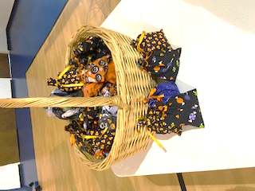

**October Outreach**

Thanks to all of you who helped to fill the Halloween bags for the MLFC.  We filled over 60 bags and they will be appreciated.

**November Outreach**

Outreach will be providing Thanksgiving meal bags for families who may need them. Please contact Luke with names of families who may be interested in receiving a bag.



**Women’s Morning Circle, Tuesday, November 15, 10:00 AM** as we study ***Celebrating Sabbath: Accepting God’s Gift of Rest and Delight****,* by Rev. Carol Bechtel. We are at Lesson #1, *Sabbath and Celebration, (*Matthew 11:28-12:13). Consider this study as an invitation to practice Sabbath in real and practical ways. Books are at the Info Table. Snacks & coffee provided.

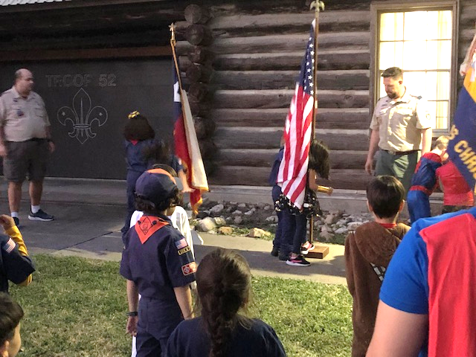

Cub Meeting at the Scout Hut.

**BSA TROOP 52 SPAGHETTI TAKE-OUT FUNDRAISER**

Sunday, November 20 11:30 am to 1:00 pm Our Troop Scoutmaster, Mr. Ordner, is a certified Food Protection Manager and all volunteers and scouts have Food Handler Cards. Thank you for supporting our youth!

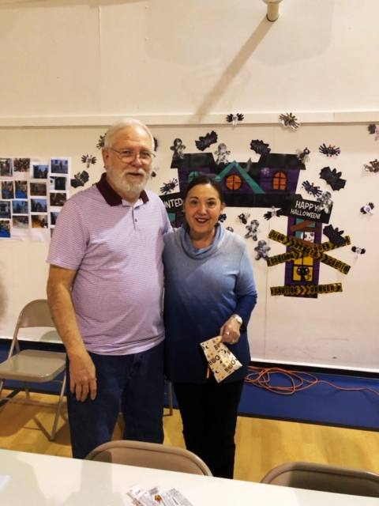

Look who showed up at Brunch Church! Good to see Ted and Debby!



**ADULT SUNDAY SCHOOL** We begin our study, ***God’s Exceptional Choice*.** We look forward to a year of The Present Word, our denomination’s adult Bible study. Every week there is an “Ah-Ha, I did not know that!” moment. Coffee and snacks provided.

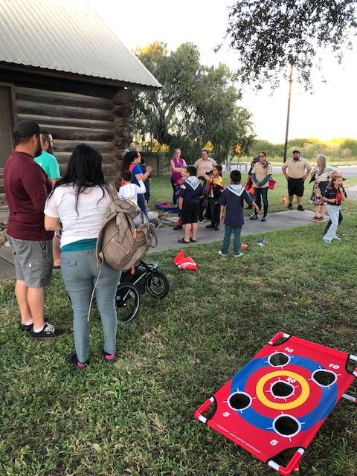

Our Cub Scout Bears organized a carnival for Cub Pack 52. Scouts and Super Heroes had fun!

**LET’S DO LUNCH!** Session and our Pastor Search Committee invite all to join us for lunch in the gym right after worship on November 6. We will talk about “where do we go from here.” PW checking account will provide sandwich trays and chips. Members are invited to bring desserts. Since JWPC will be 59 years old on November 10th we will sing “Happy Birthday” to us.



Dear JWPC Family and Friends:

It is my prayer that this letter finds you all doing well. I am reaching out to you because we, as a Church family, are once again looking forward in hope even as we face the realities of our current situation. As it has been and always will be, our hope at JWPC resides in the Lord and the good that our Heavenly Father can do through each one of us. In other words, just think about all the good that is done for the Lord through Jackson Woods Presbyterian Church. There are numerous examples some of which are outlined below:

* Attending our Morning Worship services, you can find inspiration, love, rest, community, fellowship and even reproach as we collectively worship our Lord.
* Sitting in on a Congregational Care card session, you would experience a group that routinely reaches out to members and friends in writing to let them know that Lord and Jackson Woods loves them.
* Interacting with our Cottage residents, you would see a community that is both blessed (with affordable housing) and a blessing (to anyone who happens to interact with this wonderful group).
* Delivering supplies to a local mission or gifts as part of the Angel Tree Ministry, you would experience firsthand how the many endeavors of our Outreach Committee touches lives in Northwest Corpus Christi and beyond.
* Walking into the MLFLC, you would see an organization that provides urgently needed childcare for working parents in a manner that is loving and faith based.

As described above, Jackson Woods does a lot of good in the name of our Lord and this Church family has good reason to hope that we will continue to be a part of God’s plan for this area for many years to come. That being said, the realities of our current situation are that we cannot maintain our programs without support from our Church family and friends. In other words, without your support, in the form of time, talent and/or monetary donations, JWPC cannot continue to do good in God’s name. So, as you prayerfully consider, during this Stewardship season, how and where you are going to give your resources, please remember Jackson Woods.

***Jackson Woods Presbyterian Church***

###  Faith – Promise 2023 

Through faith in Jesus Christ and a belief that God has called the Church to mission in the world,

I (we) make a Glad and Grateful Faith – Promise pledge estimate toward the

2023 General Fund of Jackson Woods Presbyterian Church.

One card per giving unit.

$_________________ Total per: **Week Month Year** (Circle One)

**__________________________________________________**

Bring this card with you to worship during our Commitment Month of November 2022 or mail to

Jackson Woods Presbyterian Church, 10500 Stonewall Blvd, Corpus Christi, TX 78410.

*Thank you for helping with our 2023 budget.*

“*Where your treasure is there will be your heart also.”*

*Matthew 6: 21*

**Thank you!**

Faith Promise Ministry at Jackson Woods Presbyterian Church supports: Mary Lois Fields Learning Center, Boy Scouting and the Scout Hut, youth and children, a pastor/supply pastor, secretary/bookkeeper, organist/pianist, custodian, power-point technician, building maintenance and updates, utilities, education resources, mission-outreach projects, worship supplies, fellowship supplies, Mission Presbytery, Synod and General Assembly.