The Joyful Noise
March 2022
Jackson Woods Presbyterian Church 10500 Stonewall Blvd Corpus Christi, 78410
Sunday School – Adults 9:30 – 10:15 a.m. Fellowship Time 10:15 – 10:30 a.m.
Morning Worship 10:30 – 11:30 a.m. Nursery Provided

MISSION STATEMENT – Jackson Woods Presbyterian Church is an inviting Christ-centered fellowship. Bringing the message of God’s grace to this community through love, service and spiritual growth.

FRONT PAGE DEVOTIONAL Kindness

When asked to write the devotional for the newsletter I first told Jean that I was not prepared to do that. We were at lunch with Jean and Elwyn and I must admit I tried to think of a topic when suddenly I blurted out “ok, I’ll do it”. Jean said do what?

Sometimes there are forces working that if we just listen, and permit them to guide us, can lead us to do things we would not ordinarily do. This week was the pledge drive for the public radio station, and one thing the announcer constantly says is “there is no pledge too small”. That can be changed to” there is no kindness that is too small”. We have experienced events in our own congregation where small acts of kindness have brought joy and relief to others. Taking someone to their doctor’s appointment because they could not drive, or perhaps calling the family that is shut in due to illness and asking if you could pick up some groceries or taking a dinner or dessert to them. When mowing your lawn, go across the neighbor’s line and help them. Small things like bringing your neighbors trash cans up from the curb can be a big help, and is not much trouble. When you take your cart to your car at HEB, if there is someone else who has finished unloading their cart, offer to take their cart to the corral. The one item which takes the least effort, but has a great effect is to smile at someone and say good morning or good afternoon.

When I was a lot younger, I was in the Jaycees and there was a lady who often recited a poem which started “I can not do every thing, but I can do some thing; I can not be every where, but I can be some where.” It does not take much effort to extend acts of kindness, but the dividends are endless.

~ Andy Phillips

MLFLC MARCH NEWS
CELEBRATE READING

Dr. Seuss Week
February 28th – March 4th
In honor of Dr. Seuss, we are going to have a Dr. Seuss Spirit Week to celebrate Reading! Each day will coordinate with one of our favorite Dr. Seuss books.
Monday- “Fox in Socks”
Wear silly or mismatched socks
Tuesday- “Green Eggs and Ham”
Wear the color GREEN
Wednesday- “Wacky Wednesday”
Let’s get silly! Wear your clothes backwards, inside out, or mismatched.
Thursday- “The Cat in the Hat”
Wear your favorite hat.
Friday- “One Fish, Two Fish, Red Fish, Blue Fish”
Wear a red or blue shirt.

PICTURE DAY
Ms. Linzy with Sweetest Snaps will be here Wednesday, March 9th and Thursday, March 10th taking Spring Pictures!!!

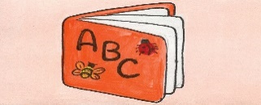
BOOK FAIR
Mrs. Sarah of Usborne Books will be setting up a BOOK FAIR for us Wednesday, March 23rd – Friday, March 25th. Books make great Easter Basket fillers! The center receives free books as proceeds from this sale!

St. Patrick’s Day Festivities
Wear Green on Thursday, March 17th as we participate in special activities throughout the day! Please check with your child’s teacher!

Enrollment: 51

Thank you to all of my amazing church family for all of your prayers and 6 weeks of driving me to the cancer center for my radiation therapy. You gave your time and loving support. I'm so blest to be a part of this JWPC family. I'm healing slowly, but have positive reports from my surgeons. Hope to be back among you soon.
Blessings, Joyce Baker

February Outreach:
Outreach would like to thank everyone that participated in the Souper Bowl last month.

March Outreach:
This month Outreach will be asking those that feel called and are able to assist JWPC in supporting Search for Truth Mission with a paper goods drive. The mission is in need of paper towels and toilet paper. We will be collecting during month of March

Women’s Morning Circle Bible Study Tuesday, March 15, 10:00 AM. We continue the study, What My Grandmothers Taught Me, Learning from the Women in Matthew’s Genealogy of Jesus, by Merryl Blair. In March we will talk about Mary in the faith and tradition of the Church. A question from the lesson, Strong, protective mother; powerful woman ruler; Our Lady; Queen of Heaven; grieving mother. Which of these images of Mary resonate the most with you? All women are invited to join Circle.

Mr. Rogers Day in the PCUSA – Sunday, March 20
We'll have a special coloring sheet for children and adults.

-Prayers, Concerns and Statements of Faith-

Our prayers are with Audrey Burge, in rehab at The Villa NW
Keep Joyce Baker in your prayers, recovering from cancer treatments
Pray for Warren Albrecht, and his continuing battle with ALS
Our prayers are with Kevin (Elayne’s stepson). He is a nurse working with COVID patients in VA.
Pray for Paislie Rothlisberger, continuing treatments for Leukemia.
Pray for Dawn Flores, Vicki & Lee Brandon’s daughter. She is receiving cancer treatment.
Keep Wendy Keach, David Mayo, and Ted Sanderfer in your prayers: Health concerns
Pray for Wendy Keach’s Aunt Deborah Harmen: Lymphoma-cancer treatments
Our prayers are with these members & friends: family and friends of Amanda Schwirtlich, Camila Oviedo, Paul Young, Wendy Williams (Nave), Marie Gray, Ann Staton, Tootsie Anderson; Mike’s mom Gayle Hallgarth; Ellen Young, Suzi Baker, Jerane's grandchildren Harrison & Kaitlyn; and Jean & Elwyn’s grandson, Kyle Droll
Keep these students attending school in your prayers: Travis Ahrens; Tootsie’s granddaughter, Crosby; Chase Dickson, Ray Hallgarth, Hadleigh Hight, Hollynn Hight, and Casey Keach.
Pray for Those in Harm’s Way - Military Service Personnel, First Responders, Healthcare Workers
Pray for the Good Samaritan Rescue Mission
Pray for the Pastor Nominating Committee
Pray for Grace Presbyterian Church

ADULT SUNDAY SCHOOL During Lent we will be looking at 3:16, The Number of Hope. This is a video series from Max Lucado. You are encouraged to read John 3:1-21. All are invited to join us in the Grace Room. Coffee and goodies provided.

MLFLC STAFF
Director Nora Pillado
Email mlflccorpus@gmail.com
Phone 361 241-8408
CHURCH STAFF
Secretary Christina Schwirtlich
Organist/Pianist Josephine Kihyun Lee
PowerPoint Tech Emilee Ahrens
Custodian Rosie Perez
Office phone 361 241-3205
Email jwpcoffice@gmail.com
Newsletter – The Joyful Noise
If you have any pictures or articles for the newsletter, please submit them to Jean Brown by the 26th of the month. ejbrown412@twc.com
JWPC Website www.jwpcc.org
If you have any pictures or suggestions for the website, please contact the church office

Ash Wednesday Worship, March 2, 7:00 PM.
We are invited to share Ash Wednesday with our friends at Grace United Methodist on FM 624. If you would like a ride, be at JWPC at 6:30 PM to carpool to Grace.

SOUPER BOWL OF CARING THANKS! Thank you to all who donated food items and cash. We collected 44 items and $90. These were taken to the Coastal Bend Food Bank.

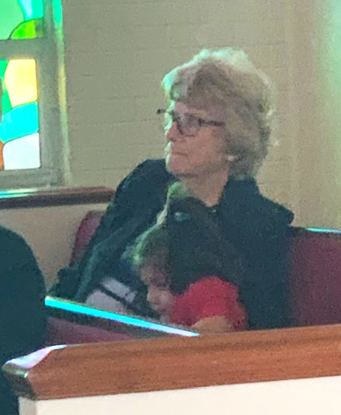
Sunday, February 27

ONE GREAT HOUR OF SHARING JWPC has taken this special offering during Lent since the beginning of this church. This offering supports disaster response, community development, refugee assistance and other programs. Presbyterian Disaster Assistance (PDA) receives funding from OGHS. Most recently PDA has offered grants to congregations recovering from the big freeze of February 2021. Special envelopes are in the pew racks.

EASTER LILIES In consideration of those who have allergies, we have silk lilies to adorn the chancel at Easter. You are invited to give a contribution to the One Great Hour of Sharing. You may give “In Memory of” or “In Honor of” a loved one. Simply use the OGHS envelopes in the pew racks and write the name in the white space on the envelope. These names will be listed in the bulletin insert on Easter Sunday.
This Photo by Unknown Author is licensed under CC BY

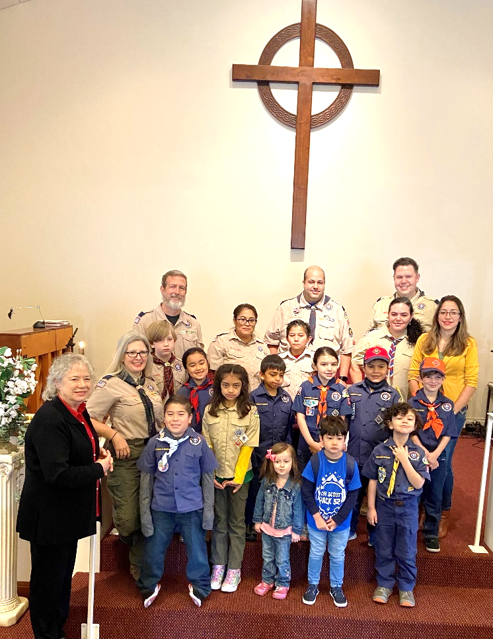
Scout Sunday, February 6

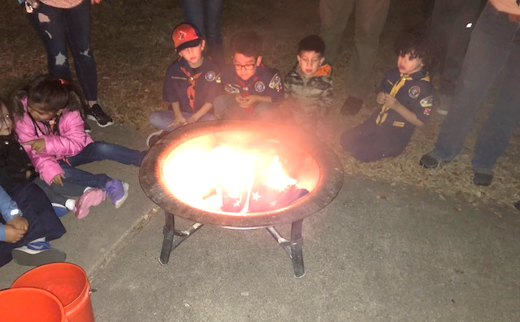
Scouts flag retirement ceremony.

Bible in 50 Words
God made.
Adam bit.
Noah arked.
Abraham split.
Jacob fooled.
Joseph ruled.
Bush talked.
Moses balked.
Pharaoh plagued.
People walked.
Sea divided.
Tablets guided.
Promise landed.
Saul freaked.
David peeked.
Prophets warned.
Jesus born.
God walked.
Love talked.
Anger crucified.
Hope died.
Love rose.
Spirit flamed.
Word spread.
God remained.

